IS Blade Concepts

Contents
1 REVISION 3
2 Introduction 3
2.1 Blade concepts 3
2.2 What is a Blade server 3
3 Integrated Site 4
3.1 IS Definitions 4
3.2 IS Infrastructure 6
3.3 IS Application Blade System 6
3.4 IS Network 6
4 Physical Layer 6
4.1 IS Sub-rack 6
4.2 Sub-Rack slot 7
4.3 Blades 8
5 Sub-rack interconnection topology 8
5.1 Network Attachment Point 9
6 IS Infrastructure Products 9
6.1 MXB 9
6.2 SIS 9
6.3 ISER 10
6.4 EXB 10
7 Application Blades 11
7.1 MGW – Media Gateway Blade 11
7.2 TGC/MG-IC– TSS Gateway Controller Blade / MGW inter-connect 12
8 ISI Jumpstart instruction for IS 1.2 14
8.1 Jumpstart Server 14
8.2 Prerequisites for the Jumpstart Procedure 15
8.3 IS Software Load 15
8.4 Conections to Jumpstart Server 16
8.5 BIOS settings 16
8.6 Update the MAC Address 18
8.7 The Jumpstart 18
8.8 Create Blade Systems 19
9 Netconf (IS Configuration and Management with scripts) 20
9.1 How to use Netconf 20
9.2 Netconf hello message 20
9.3 BLIPP, the Blade Input Pre-Processor 21
10 Document references 21

REVISION

Rev | Description
PA1 | This is the preliminary revision of document.

Introduction
The purpose of this document is give an overview of the IS Blade, and introduce basic IS Concepts and Terminology. As well as the IS Infrastructure products and they interfaces and physical layer.

Blade concepts
Now a days the inclination of the technology it’s the miniaturization of the systems, a complete node can feet now into a simple board, this have some benefits:
- Save Space
- Save Energy
- Less warming
- ETC

These are important points in the competitive environment of business today.

What is a Blade server
A Blade server fits into a cabinet like a book into a bookshelf, and it’s a independent server, with his own memory, processor, data storage, network controller, operating system and applications, This blades simply slide into a cabinet and plug into a mid or/and back plane. Sharing power, fans, floppy drives, and ports whit others blade servers. The blade server has a lot of benefits like less cables running down to add or remove servers, save space switches and power units shared.

Integrated Site
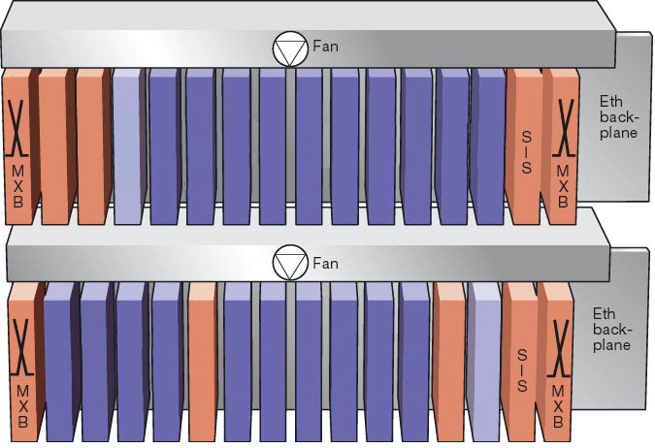
The targets of the integrated site are to take a widely deployed network into a site, offering a layered framework for the nodes from a Network using open standard network interface. This make the application nodes act as network elements in the IS.

IS Definitions

IS CENTRAL OAM (ISCO)
This functionality is singular within IS. It resides on the Site Infrastructure Support Node (SIS) and provides a number of IS internal services to the Blade Systems in terms of boot-loading, management support, configuration, fault management, network file system (NFS), etc. These are more thoroughly described in the Management View section.
IS Central OAM will only to a limited extent be aware of how a Blade System are internally organized. Blades are visible to ISCO only when performing HW management, boot loading and layer 2 fault management.

IS INTERNAL OAM SUBNETS
IS internal OAM subnets are in some aspects different from the trafficable subnets handled by IS.
They carry IP packets but the traffic is strictly confined to the IS LAN domain. No routing function will ever be attached to these subnets.
The IS Internal OAM Subnets relevant to Application Blade Systems are:
· IS Boot Subnet (ISBS)
Network prefix: 169.254.128 /18
· IS OAM Basic Subnet (ISOB)
Network prefix: 169.254.0 /18
· IS OAM Supplementary Subnet (ISOS)
Network prefix: 169.254.64/19
In addition to that, there is a reserved network prefix for Blade internal communication
· IS Blade Internal Subnets (ISBI)
Network Prefix: 169.254.192 /20
In addition to these, the BS (or BS:s ) implementing ISCO may need and be granted BS private subnets (as may any BS). However, in the case of ISCO BS:s, the addresses for this purpose are allocated from the predefined range of Link Local addresses as stated beneath:
· IS Infra-structure OAM Subnets (ISIS)
Network prefix: 169.254.96/19
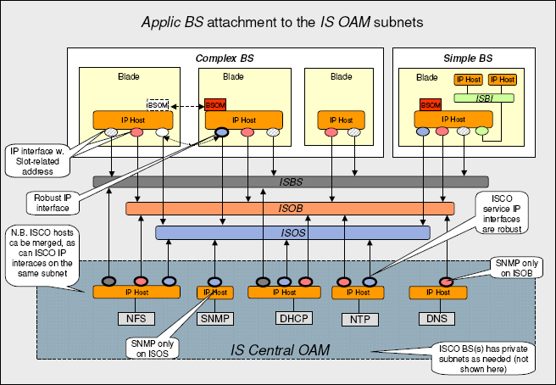

BLADE SYSTEM OAM MASTER
Each Blade System includes exactly one BS OAM Master (BSOM). The Blade System OAM Master takes care of most of the interactions with ISCO on behalf of the Blade System. A BSOM is signified by its IP address.
It is up to the Blade System designer to decide which Blade or Blades that may assume the master role. If more than one Blade potentially can do so, the selection may involve a run-time arbitration process. The role may also be moved in run-time from one Blade to another in case of failures. Since this role is associated with a certain IP address on the ISOS and that this IP address, by moving, will be related to another MAC-address, ISCO must be forced to update its ARP-cache should the address move. To ensure this to happen, a Blade assuming the BSOM role must issue a gratuitous (i.e. uncalled for) ARP message.

IS Infrastructure
The IS Infrastructure define the implementation of the IS common resources. SYS, ISER and MXB are examples of boards implementing IS common resource, In the future other common resources will be considered for the IS Infrastructure.

IS Application Blade System
Defines the implementation of an application complying to the IS Framework

IS Network
Defines the Domain of the IS common resources handled by one HW and SW configuration services.

Physical Layer

IS Sub-rack
The IS sub-rack is a basic physical concept of IS. All (Blade) systems inserted into a IS Sub-rack will be required to fully comply with the IS architecture. Up to 32 are supported from an architectural aspect.
A possible exemption is to allow an IS sub-rack to also house boards with no other IS provision than power supply. Even in this case it must be possible for the IS Central O&M to communicate with these boards via the management bus in order e.g. to perform HW inventory.

Sub-Rack slot
A Substantial part of the IS configuration is related to the sub-rack slot concept, each slot has a slot number and a sub-rack number (address plug) and slot number (fixed per position) uniquely identifies a physical board position within IS.
The back-plane connector for each slot includes multiple physical attachment points. Two of these connect to the 1Gbps IS LAN, two (or sometimes one depending on the bus type) connects to the IS Management bus and the optional two connects to the 10Gbps IS LAN. The dual attachment to a physical port is for resiliency, not for capacity.

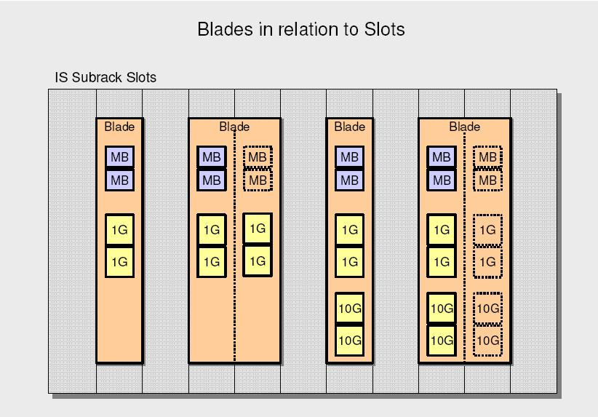
IS allow Blades to straddle multiple slots attach to the 1 Gbps network in each one of these slots. This will e.g. give a Router Blade a Bandwidth of 2Gbps
In doing IS, the blade must NOT perform Link aggregation between Links of different Slots. Furthermore the Blade itself would have to provide mechanisms for load sharing between links.

Blades
Empty slots will for natural reasons not have any blade connected to the back-plane. A slot may also be occupied by HW not connected to the back-plane. This is because the space such slots represents is occupied by a blade in adjacent slot.
An important architectural rule in this context is that:
When a blade straddles more than one slot, it must only connected to the IS Management Bus in one of these slots (the Left-most one).
Future IS versions will include multiple Blades within a single slot, these Blades will be carried by a “mother Blade”. The IS Architecture is prepared for this extension and will be complemented as needed to handle these physical structure.

Sub-rack interconnection topology
Multiple IS sub-racks may be interconnected to form a larg IS domain. The first supported topology will sub-rack in cascade.
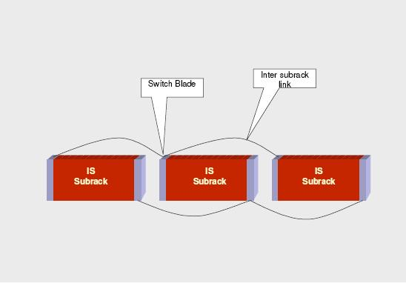
Nothing in the architecture prevents other topologies, like e.g. a star or mix of the two to be supported in the future. The architectural limit (addressing space) is up to 32 IS sub-racks.

Network Attachment Point
This is a physical connection to a network. In IS there are three kinds of network Attachment Points to the IS back-plane.
IS Management Bus (M-bus or IPMI)
1000BaseT (I Gbit Ethernet)
XAUI (10 Gbit Attachment Unit Interface)

IS Infrastructure Products
The IS Infrastructure Release 1 products includes;
The housing for Blades (IS sub-rack) and basic functionality for site O&M and the Site LAN capabilities. Which constitute the mandatory parts of the IS Infrastructure.
Switch extension for connecting external equipment and edge router with security functions, both of which are optional parts of the IS Infrastructure.
Other optional parts of the IS Infrastructure as the Signaling Gateway or Signaling Proxy are included as part of the Release 1 infrastructure.

MXB
Shelf Manager. - IPMI (ATCA compatible), M-Bus (GEM compatible).
This is an Ethernet switch, support VLAN and had 24x 1GE, 22 back-plane Base-T and 1 control crosslink, this blade occupies 2 slots (30mm).
The MXB work in redundant pair’s whit load sharing, failover between the switches take place in 100ms, if the MXB control processor goes down, the switch data plain continue forward traffic until the blade system detects the failing switch blade system and re-direct traffic to the fault-free switch blade system.

SIS
LCT Interface. - Ethernet and RS-232, this blade occupies 2 slots (30mm), The SIS System provides many common support functions for the integrated site. Like SW Management, HW management, IS management, Fault Management, IS Support functions- NTP server, DHCP and boot server, DNS server, LDAP server, GUI Element Manager.
The SIS Blade system is a mandatory part of the Integrated Site and consists of 2 boards in order to de resilient. There is one active board and one passive, the passive board is continuously update with information so that it can take over if the active SIS board should fail because sever hardware or software error.
The SIS blade system is implemented in a 1+1 cold-standby redundant processor Blade pair. Failover take place within 15s at failure, the standby SIS Blade will take-over the service IP address and resume the execution. Un-served service request will be re-sent by Blade system until they get the served. The Blade system uses a data base with the precise information of the process is stored persistently. If one process is restarted, it can fetch the information from the database and continue execution. This means, that at failover, the process instances started on the redundant processor use current information.

ISER
This blade occupies 2 slots, support routing protocols like BGP, OSPF, IS-IS, RIP, furthermore support 64 Virtual Routers Instances. The ISER had 2x 2*GE IS Back-plane connection and 4x GE Uplink SFP for Base-T or Optical.
IS edge router is a router integrated in the blade system, to provide L3 IP services to the nodes in the blade system framework, ISER provides a common router instance and common network interface. More specifically the service offered is L3 routing, QoS, L3 resiliency, traffic separation, encryption, stateless security filtering and tunneling.
The ISER has virtual routing capability making it act as several virtual routers on the same HW, The configuration of the different virtual routers in centralized
To achieve redundancy, two ISERs blades must be configured to back up each other with VRRP and ordinary network routing protocols. At ISER failure, the backing up the failure ISER will take over all the outgoing traffic, by means of VRRP. For IS incoming traffic IS exterior re-routing is used to recover connectivity. At failure, outgoing traffic is disrupted for ~0.5- 1s and incoming traffic for ~5s.

EXB
This Blade occupies 1 Slot (15 mm), it’s an Ethernet switch with resilient backplane termination selectable for 10GE XAUI or/and 1GE Base-T, furthermore had 20xGE/FE front connector Base-T and auto negotiation.
This optional IS LAN External Attachment function has sole purpose to extend the IS LAN connectivity to externally attached system, providing various LAN devices with a well-defined, non-resilient data link layer connectivity, supporting traffic separation and differentiation as needed by various Attached Systems applications.
This data link layer connectivity is provided to the attached System (ATS) via front ports on the IS LAN EXB, through interfaces based on the widely used and recognized Ethernet standards framework as maintained by the IEEE LAN-MAN Standards Committee, IEEE 802.

Application Blades
The application of the sub-rack its defined by the Application Blades that could have different applications like the followings. Forward in the document are described the MGW and TGC application blades.
- Current:
  - MGW – STM-1 Media Gateway
  - MGC – Media Gateway Controller
  - SBG – Session Border Gateway
  - TGC – TeS Gateway Controller
  - MG-IC – Media Gateway Inter-connect
- Planned:
  - CSCF, HLR, TSP, AGC, HSS, Storage Blade, MSC-S, BSC, APZ-214-01,

MGW – Media Gateway Blade
- All MGW functionality contained on a blade
- 3 Slot wide blade based on the
- Full STM1/OC3 support per blade (DSP per channel)
- Scalability by just adding blades
- Multiple voice codec support
  - G.711, G.726, G.723.1, G.729A/B, AMR, EVRC
- Fax
  - T.38 / Voiceband fax
- Video support
  - H.323 terminal to SIP/H.323
  - transcoderfree operation of H.263 baseline, H.263 v2, MPEG-4 and H.264
- IP to TDM and IP to IP calls
- H.248 Tispan TGW profile support
- Multiple blades controlled via one H.248
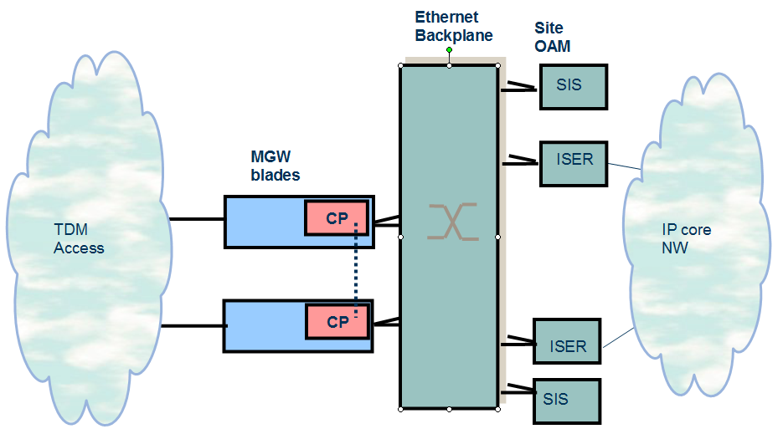

TGC/MG-IC– TSS Gateway Controller Blade / MGW inter-connect
- TGC application blade provides the conversion of signalling from the TeS to H.248 for controlling the gateway blades
- Deployed in pairs
- TGC uses the GEP hardware blade and can handle up to 150cps per processor pair
- MG-IC utilises the MGW blade to provide conversion from STM-1 TDM to Ethernet IP for media such as announcements from the TeS to the softswitch network
- Each MGW card is currently 1:1 protection on the same 3-slot width blade
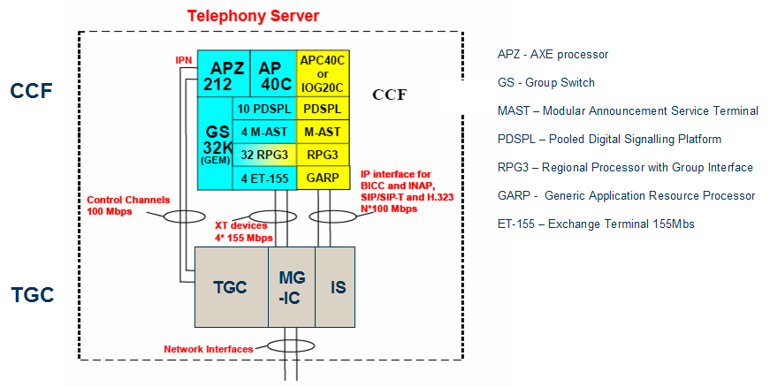

ISI Jumpstart instruction for IS 1.2
Ref. 1/1531-HSC 901 63-2 Uen

Jumpstart Server
The jumpstart procedure is performed by a server with this services
- NTP
- FTP
- TFTP
- DHCP
- NFS
- SSH (optional)

NTP
The Network Time Protocol (NTP) is a protocol for synchronizing the clocks of computer systems over packet-switched, variable-latency data networks.

DHCP
The Dynamic Host Configuration Protocol (DHCP) automates the assignment of IP addresses, subnet masks, default gateway, and other IP parameters.
A DHCP server must be running and be properly configured. Since DHCP, during jumpstart, interacts with both TFTP and NFS, it is a good idea to check the configuration for TFTP and NFS while configuring DHCP.

TFTP
Trivial File Transfer Protocol (TFTP) is a very simple file transfer protocol, with the functionality of a very basic form of FTP. During boot TFTP is used to transfer the boot images stored under tftp server root directory for example. “/tftpboot” .

NFS
Network File System (NFS) is a network file system protocol, allowing a user on a client computer to access files over a network as easily as if the network devices were attached to its local disks. For IS installation purposes NFS is used to transfer the IS SW to SIS.

FTP
An FTP server is needed to transfer files (SW, backups, logs, ISP files and so on. ) to and from the IS node. It is not needed during the actual jumpstart but it is a good idea to have one configured and ready to use from the start.
There are a number of ftp servers available and the configuration can differ a lot between different vendors.

Prerequisites for the Jumpstart Procedure
- Depending on the lab infrastrucure, the following hardware and software tools are needed to perform the procedures:
  - A jumpstart server with required IS software in place
  - All cabling is done
  - Torx screwdriver, size T8
  - A computer with a web browser with Java plug-in 1.4.2 or higher, to be connected remotely or locally. The jumpstart server can be used.
  - A dumb VT100 terminal or a computer with a terminal emulator for example minicom on Linux
  - 2 SIS and 2 MXB’s is a minimum for jumpstart. Additional boards can be included at a later stage.

IS Software Load
- The Software can be loaded in to different ways to the IS Blade.
  - During the Jumpstart via NFS
  - After the Jumpstart via FTP
- The minimum software needed to perform a Jumpstart its the software for SIS and MXB.

Conections to Jumpstart Server
- A serial connection to both SISs and preferably both MXBs.
- An ethernet connection to ETH1 on both SIS from jumpstart server. Figure 1 shows the layout.
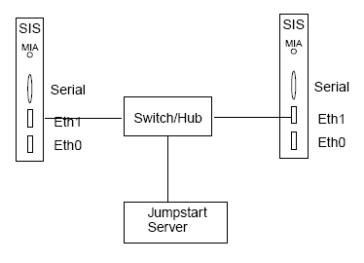

BIOS settings
1. Make sure that the RS-232 serial communication protocol configuration in the SIS console terminal is set up for:
- Speed: 38400 bit/s
- Data bits: 8
- Parity: None
- Hardware flow control: Yes
- Software flow control: No
2. Reset/reboot SIS
- When there is activity in the console window press F4 to enter BIOS.
- Depending on the terminal you may need to press DEL or BKSP.
3. Navigate to boot order menu.
4. With respect to the factory default settings the following should be changed:
- Boot Settings -> Boot Settings Configuration:
  - Quick Boot Enabled
  - Wait For ’F1’ If Error Disabled
- Boot Settings -> Boot Device Priority:
  - 1st Boot Device SM-FUJITSU ... SEE NOTE!
  - 2nd Boot Device IBA GE Slot 0319
  - 3rd Boot Device IBA GE Slot 0318
  - 4th Boot Device Disabled
- Advanced Chipset Settings -> Onboard Gbit Ethernet Configuration:
  - Ethernet 1 (IBA slot 318) Enabled <-no change, already set
  - Ethernet 0 (IBA slot 319) Enabled <-no change, already set
  - Ethernet 2 (IBA slot 310) Enabled
  - Ethernet 3 (IBA slot 311) Enabled
NOTE:
In order to allow the unit to network boot from the front interface GE#1 and perform the SW loading it is necessary to temporarily set the 4th Boot Device to: IBA GE Slot 0311. After SW load the boot settings must be restored to what is shown above.
5. Save and reboot

Update the MAC Address
Log into the SIS and do
#ipconfig –a
Search in the print out the MAC address of the Interface ETH1
eth1 Link encap:Ethernet HWaddr 00:20:CE:D1:65:71
inet addr:146.250.3.75 Bcast:146.250.255.255 Mask:255.255.255.0
UP BROADCAST NOTRAILERS RUNNING MULTICAST MTU:1500 Metric:1
RX packets:13525953 errors:0 dropped:0 overruns:0 frame:0
TX packets:665446 errors:0 dropped:0 overruns:0 carrier:0
collisions:0 txqueuelen:1000
RX bytes:975859998 (930.6 Mb) TX bytes:147137307 (140.3 Mb)
Base address:0xd880 Memory:ffca0000-ffcc0000
Make a note of the mac address and update “/etc/dhcpd.conf” with correct address.
Repeat on the other SIS and restart dhcpd on the jumpstart server.
#/etc/init.d/dhcpd restart

The Jumpstart
If SIS is allready installed it needs to be forced to boot from network.
1. Login to both SIS and do:
#sudo changeboot.sh -erasembr
2. Reboot both SIS.
If the GUI is available perform a system restart from the GUI otherwise do:
#reboot
3. Login and check for the drbd sync
#cat /proc/drbd
4. When there’s no progress bar and you can see a similar string:
cs:Connected st:Primary/Secondary ld:Consistent
the sync is finished.

Create Blade Systems
1. To monitor the MXB’s connect your terminal console to MXB’s.
The terminal settings for MXB/EXB/ISER are:
- Speed: 115200 bit/s
- Data bits: 8
- Parity: None
- Hardware flow control: Yes
- Software flow control: No
2. Make sure you have IP connectivity to SIS.
3. Use your web browser to connect to the ISM. (http://<SIS1 ip address>).
See also dhcp.conf.
SIS1 is usally primary. If the connection fails, try to connect to SIS2 instead.
4. In ISM navigate to:
Integrated Site Services → Hardware
Press Create Blade System
Press Create
5. Navigate to Integrated Site Services → Hardware → Open Blade Systems .
After a couple of minutes there should be three BS, one for the SIS and one for
each MXB.

If not
Use the terminal console on MXBs and check for activity. If the terminal console
is not available, Check the event log for “swup” events.
If no activity can be noticed wait ~20 min and reset the MXBs manually.

Netconf (IS Configuration and Management with scripts)
NETCONF is a standardized interface for configuration purposes, Beside the ISM GUI it can be used for (much faster) IS and blade system network configuration,
as well as TGC and MGw application configuration. Nowadays XML configuration files are created by a tool called BLIPP.

How to use Netconf
NETCONF uses ssh as "transport and authentication layer". Typical commands to bulk-load a NETCONF file into an IS systems look like:
- (1.x) ssh -p 2223 expert@is-0xx-isnb -s netconf < input.xml
- (2.0) ssh -p 830 expert@is-0xx-isnb -s netconf < input.xml

Netconf hello message
The hello message its mandatory to start the netconf configuration.
<?xml version="1.0" encoding="UTF-8"?>
<hello xmlns="urn:ietf:params:xml:ns:netconf:base:1.0">
<capabilities>
<capability>urn:ietf:params:netconf:base:1.0</capability>
</capabilities>
</hello>
]]>]]>

BLIPP, the Blade Input Pre-Processor
BLIPP is a tool to create configuration scripts for Integrated Site (IS) systems. It greatly saves on typing, reduces errors introduced through copy paste, speeds up the creation and maintenance of configuration scripts while at the same time giving a better overview over the configuration.
The input is a simple text-file which can be edited in any text editor, it can be easily put under revision control (for example ClearCase). Having the input as a plain text file it is possible to compare two files or two revisions of the same file for changes or differences.
The output is a NETCONF XML file that can be imported into an IS node.

Document references
Integrated Site Overview (STUDENT BOOK)
LZT 123 8087 R1A
ISI Jumpstart instruction for IS 1.2 (HSC 901 63 R3)
1/1531-HSC 901 63-2 Uen Rev D
IS Plataforms and Nodes
http://info.eed.ericsson.se/article/IS_Platform_and_Nodes#NETCONF_and_XML
blipp
http://info.eed.ericsson.se/article/blipp

